Pupil premium strategy statement

This statement details our school’s use of pupil premium (and recovery premium for the 2021 to 2022 academic year) funding to help improve the attainment of our disadvantaged pupils.

It outlines our pupil premium strategy, how we intend to spend the funding in this academic year and the effect that last year’s spending of pupil premium had within our school.

School overview
Detail | Data
School name | Castlechurch Primary School
Number of pupils in school | 259  YR-Y6
Proportion (%) of pupil premium eligible pupils | 33%
Academic year/years that our current pupil premium strategy plan covers (3 year plans are recommended) | 2021-2024
Date this statement was published | September 2022
Date on which it will be reviewed | Jan 2023  March 2023  July 2023
Statement authorised by | Mrs E Goodyear
Pupil premium lead | Mrs E Goodyear
Governor / Trustee lead | Mrs V Bowyer
Funding overview
Detail | Amount
Pupil premium funding allocation this academic year | £ 121,880
Recovery premium funding allocation this academic year | £ 12,760
Post LAC funding | £ 7,230
Pupil premium funding carried forward from previous years (enter £0 if not applicable) | £ 0
Total budget for this academic year  If your school is an academy in a trust that pools this funding, state the amount available to your school this academic year | £ 141,870

Part A: Pupil premium strategy plan

Statement of intent
Castlechurch Primary School offers a positive, inclusive, safe learning environment for its learners, in which everyone has equal and individual recognition and respect. We celebrate difference and are committed to the continuous improvement and fulfilment of potential in every child. We encourage increasing independence and confidence amongst the children. Everyone within the school has an important role to play in sharing responsibility for the development of positive attitudes to learning and excellent behaviour.

We have high aspirations and ambitions for our children and we believe that every child can achieve. By undertaking the approach of ‘profile, predict and prevent’ in our Triple A Strategy, Castlechurch Primary School aims to achieve the following for all DA pupils.

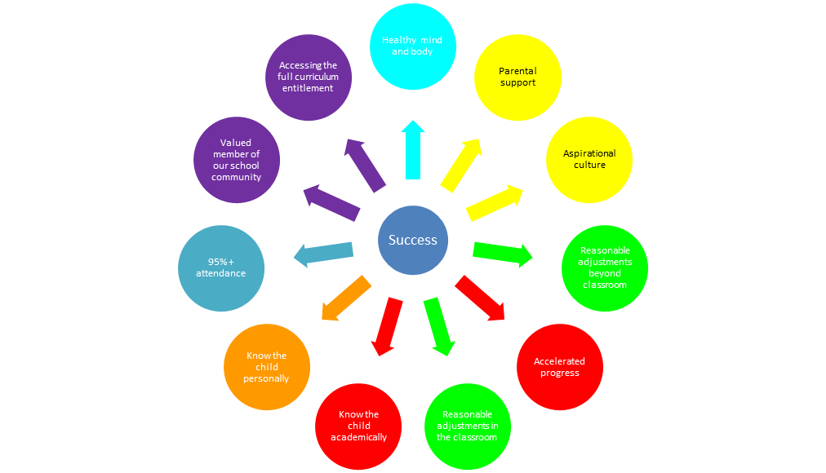
By doing so we believe we will have an impact on pupils:
- self-esteem and confidence
- progress and achievement
- attitude towards learning and attendance
- well-being and mental health
- access to their full curriculum entitlement

Our Key principles to achieve this success are:
- Quality First Teaching including deployment
- Aspirational Mindset
- Leadership
- Cultural Capital
- Attendance & Behaviour
Castlechurch has an Inclusion Link and the Children First Learning Partnership has an Inclusion Champion whose roles include ensuring our multi academy trust provides ambitious provision which to aspires close any attainment gaps and ensures all pupils who are disadvantaged access their full curriculum entitlement. This will be done via termly monitoring of the PP budget and PP strategy alongside observing provision, talking to pupils and talking to staff.

Challenges

This details the key challenges to achievement that we have identified among our disadvantaged pupils.
Challenge number | Detail of challenge
1 | Poor Attendance, in particular Persistent Absenteeism is above the national average and has been consistently over the last few academic years
2 | Half of all identified children are working below the national average attainment level and 20% are on the SEND register. Needs tend to be centred around poor communication and literacy and becomes very apparent when looking at year group attainment data:  Writing (Summer 2022)  YR 63% at working at ARE, Y1 62%, Y2 71%, Y3 60% Y4 27% Y5 62%  Reading (Summer 2022)  YR 63% at working at ARE, Y1 62%, Y2 71%, Y3 60% Y4 27% Y5 62%
3 | We have low baseline data scores for our Reception children with large numbers working below in the PRIME areas of the EYFS curriculum  CAL 23% OT, PD 23% OT and PSED 54% OT. These areas need addressed before our Reception children are ready to learn in the specific areas
4 | Assessments, observations, and discussions with pupils suggest disadvantaged pupils generally have greater difficulties with phonics than their peers. This negatively impacts their development as readers.
5 | Transitions between classes and schools cause difficulties with many children in this cohort. They typically show that they regress in their both their ability and confidence levels meaning accelerated progress is needed just to make expected progress. Children struggle to reflect on their learning, acknowledge their strengths and apply skills in different areas
6 | There is a lack of appropriate engagement from parents in additional school learning activities coupled with low parental expectations for learning behaviours and outcomes
7 | Access to and involvement in a full curriculum entitlement is restricted for some. This includes quality extra curricular clubs, school trips and residential, learning resources, appropriate kit and uniform and pupil leadership roles

Intended outcomes
This explains the outcomes we are aiming for by the end of our current strategy plan, and how we will measure whether they have been achieved.
Intended outcome | Success criteria
To achieve and sustain improved attendance for all pupils, particularly our disadvantaged pupils. | Sustained high attendance from 2024/25 demonstrated by:  - the overall absence rate for all pupils being no more than 8.2% (national) and the attendance gap between disadvantaged pupils and their non-disadvantaged peers is beginning to reduce  - the percentage of all pupils who are persistently absent being below national figure of 8.2% and the figure among disadvantaged pupils being more inline than their peers
Improved writing attainment among disadvantaged pupils at the end of KS1 and KS2 | KS1 and KS2 Writing outcomes in 2024/25 show that an increased % of disadvantaged pupils met the expected standard. Internal tracking will predict and maintain ambitious flightpaths for disadvantaged children
Improved reading attainment among disadvantaged pupils including phonics at the end of KS1 and KS2. | Phonics Screenings data, KS1 and KS2 Reading outcomes in 2024/25 show that an increased % of disadvantaged pupils met the expected standard. Internal tracking will predict and maintain ambitious flightpaths for disadvantaged children
Improved oral language, physical, personal and social development skills providing the platform for more formal learning in KS1 | Assessments and observations indicate significantly improved oral language, physical, personal and social development among disadvantaged pupils. This is evident when triangulated with other sources of evidence, including engagement in lessons, Evidence me and ongoing formative assessment.
Improved self assessment, motivation and belief in their learning capabilities among disadvantaged pupils | Sustained high levels of participation in pupil conferences and marking and feedback from 2024/25 demonstrated by:  - qualitative data from pupil voice, pupil and parent surveys and teacher observations  - a significant increase in participation in assessment and learning activities, particularly among disadvantaged pupils
Regular attendance of disadvantaged parents in a wide variety of school engagement activities | Records show:  - An increased engagement in activities  - Increased completion of parent surveys  - Thriving PTFA committee  - Use of social media to promote the school and parental events
Increases attendance of disadvantaged pupils on trips, residentials, school run extra-curricular clubs and external local sporting membership | Increased number of disadvantaged children on registers for clubs, trip, residentials  School is represented in local sporting clubs by disadvantaged pupils

Activity in this academic year
This details how we intend to spend our pupil premium (and recovery premium funding) this academic year to address the challenges listed above.

Teaching (for example, CPD, recruitment and retention)
Budgeted cost: £ 97, 325
Activity | Evidence that supports this approach | Challenge number(s) addressed
Enhancement of our teaching of the Writing curriculum planning in line with DfE and EEF guidance.  We will fund teacher release time to embed key elements of guidance in school and to access External and internal English Networks and support | https://educationendowmentfoundation.org.uk/education-evidence/guidance-reports/literacy-ks-1  https://educationendowmentfoundation.org.uk/education-evidence/guidance-reports/literacy-ks2 | 2
Implementation of Little Wandle (a DfE validated Systematic Synthetic Phonics programme) to secure stronger phonics teaching for all pupils and a higher % of DA children met the expected standard | Phonics approaches have a strong evidence base that indicates a positive impact on the accuracy of word reading (though not necessarily comprehension), particularly for disadvantaged pupils:  Phonics | Toolkit Strand | Education Endowment Foundation | EEF | 4
Embedding self assessment, reflection and responses to marking and feedback in order for children to evaluate their own work effectively in order to improve engagement | https://educationendowmentfoundation.org.uk/education-evidence/teaching-learning-toolkit/metacognition-and-self-regulation  https://educationendowmentfoundation.org.uk/education-evidence/teaching-learning-toolkit/feedback | 5
CPD for staff to introduce mastery approach in lessons initially in Maths, English and moving to Non core lessons to increase the number of children working at ARE. Ensure children receive preteach sessions to ensure they keep up with ARE objectives | Mastery learning | EEF (educationendowmentfoundation.org.uk) | 2

Targeted academic support (for example, tutoring, one-to-one support structured interventions)
Budgeted cost: £ 34,545
Activity | Evidence that supports this approach | Challenge number(s) addressed
Additional phonics sessions targeted at disadvantaged pupils who require further phonics support. | Phonics approaches have a strong evidence base indicating a positive impact on pupils, particularly from disadvantaged backgrounds. Targeted phonics interventions have been shown to be more effective when delivered as regular sessions over a period up to 12 weeks:  Phonics | Toolkit Strand | Education Endowment Foundation | EEF | 4
Use of Speakwrite (Private Speech and Language therapist) to provide sessions to improve listening, narrative and vocabulary skills for disadvantaged pupils who have relatively low spoken language skills initially in the Early Years. | Oral language interventions can have a positive impact on pupils’ language skills. Approaches that focus on speaking, listening and a combination of the two show positive impacts on attainment:  Oral language interventions | EEF (educationendowmentfoundation.org.uk) | 3
Additional physical development sessions targeted at disadvantaged pupils who require both fine and gross motor support in the Early Years in readiness for writing | https://educationendowmentfoundation.org.uk/education-evidence/early-years-toolkit/physical-development-approaches | 3,2
Additional reading opportunities for targeted children to support and develop reading fluency. Targetted preteach sessions to support prosody and comprehension | Reading comprehension strategies | EEF (educationendowmentfoundation.org.uk) | 2

Wider strategies (for example, related to attendance, behaviour, wellbeing)
Budgeted cost: £10, 000
Activity | Evidence that supports this approach | Challenge number(s) addressed
Embedding principles of good practice set out in the DfE’s https://www.gov.uk/government/publications/working-together-to-improve-school-attendancadvice  Use VIP Education to increase the support and challenge to DA families including additional attendance clinics to overcome barriers and implement new procedures to improve attendance | The DfE guidance has been informed by engagement with schools that have significantly reduced levels of absence and persistent absence. | 1
Offer Breakfast club provision to improve attendance of some children and ensure children are ready to learn | Magic Breakfast project EEF saw +2 months academic progress at Y2 and improvements in behaviour and readiness to learn  Magic Breakfast | EEF (educationendowmentfoundation.org.uk) | 1
Use OWL (Outdoor Wisdom and Learning) to provide Forest School sessions in order to promote self reflection, resilience, problem solving and teamwork in practical situations | https://educationendowmentfoundation.org.uk/education-evidence/teaching-learning-toolkit/metacognition-and-self-regulation  https://literacytrust.org.uk/resources/early-words-together-two-outdoors/ | 3, 4
Incentives to encourage pupil school attendance and parental engagement in school activities, learning workshops and PTFA events | https://educationendowmentfoundation.org.uk/education-evidence/teaching-learning-toolkit/parental-engagement | 6
Increase cultural capital by providing experiences to widen children’s knowledge of the arts, science and technology. Increase access to extra-curricular sports clubs and music lessons | Arts participation | EEF (educationendowmentfoundation.org.uk) | 7

Total budgeted cost: £ 141,870

Part B: Review of outcomes in the previous academic year

Pupil premium strategy outcomes
This details the impact that our pupil premium activity had on pupils in the 2021 to 2022 academic year.
Attendance (June 2022)
- Current PA data for PP is 10.9% which equates to 10 children. This has reduced 6.1% from December 2021 (5 children)
- This compares to 14.2% Non PP which equates to 22 children
- School is now playing for xxx children to attend breakfast club to support attendance.
- Overall attendance is 95.1% for PP which is 1% lower than Non PP (96.1%)
- Graduated response for attendance is now in place and teachers have taken responsibility for attendance issues that are beginning to decline.
Writing Attainment June 2022
- KS1 SATS Writing Teacher Assessment data for PP. 71.4% OT & GDS. 0% GDS. This has increased by 8.6% from Data 1.
- KS2 SATS Writing Teacher Assessment data for PP 53% with 6.7% GDS. This has improved by 10% since data 1 and 6.7% GDS
Reading attainment June 2022
- 69.2% PP Y1 Phonics data (9 out of 13) this compares to Non PP 86.2% (25 out of 29)
- KS1 SATS Reading Teacher assessment for PP 71.4% which has improved by 9.4% from Data 1
- KS2 Reading Teacher assessment is 53% with 20% GDS this has improved from Data 1 by 3% and 13% GDS
- In comparison to KS1 Data (value added) it is the same 53% with 20% GDS
EYFS Prime areas June 2022
- PP EYFS Data 1
CAL 20% OT, 50% PSED, 10% PD
- PP EYFS National Data June 2022
CAL – List & Att 72.9%, Speaking 90,9%
PSED – Managing self 90.9% &, Self regulation 81.8% & Build rel 72.7%
PD – Gross motor 100%, Fine motor 81.3%
Learning behaviours June 2022
- Pupil Voice & Maths Triad results demonstrate that pupil have a positive attitude to learning and are beginning to display metacognitive behaviours and can state what resources and strategies they can use to support
- New Maths/English pathway powerpoints include metacognitive questions to prompts staff to use their questions and encourage staff and children to discuss learning strategies/prompts/resources to help themselves be successful.
Parent Engagment June 2022
- All classes have had a craft/topic themed parent engagement session as well as forest school parent engagement. All events have been well attended.
- PTPA Summer fair organised
- Sports day for y1-6 and EYFS organised and attended by parents
- Parent Questionnaire completed by 24 parents EYFS and 73 parents Y1-6
Wider curriculum June 2022
- PP attendance at clubs are analysed and shares with LAB
Club | Year group | Total in club | DA
Yoga | Y1/2 | 17 | 5
Collage | Y1/2 | 8 | 2
Colouring | Y1/2 | 23 | 9
Digital Art | Y3/4 | 15 | 8
Cross Stitch | Y3/4 | 14 | 4
Times tables | Y3/4 | 18 | 9
Cricket | Y5/6 | 14 | 4
Lego | Y3/4 | 23 | 11
Netball | Y5/6 | 13 | 5
Embroidery | Y5/6 | 10 | 3
Gardening | Y5/6 | 9 | 4
 | TOTALS | 164 | 64
- Music lessons offered at reduced price after taster sessions so far 5 children have taken up this offer
- Y5 Blue Peter trip organised and paid for through PP to ensure full participation and engagement for PP. 20 children attended from Y5.

Externally provided programmes
Please include the names of any non-DfE programmes that you purchased in the previous academic year. This will help the Department for Education identify which ones are popular in England
Programme | Provider

Service pupil premium funding (optional)
For schools that receive this funding, you may wish to provide the following information:
Measure | Details
How did you spend your service pupil premium allocation last academic year?
What was the impact of that spending on service pupil premium eligible pupils?

Further information (optional)
Use this space to provide any further information about your pupil premium strategy. For example, about your strategy planning, or other activity that you are implementing to support disadvantaged pupils, that is not dependent on pupil premium or recovery premium funding.

